Step1:
Write the code in C language file p1 inside project directory
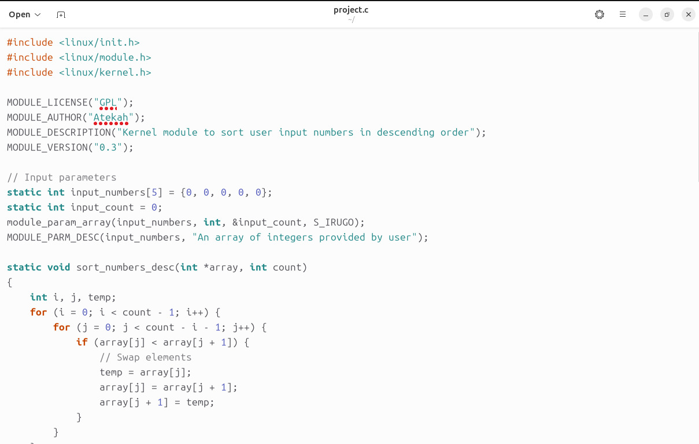
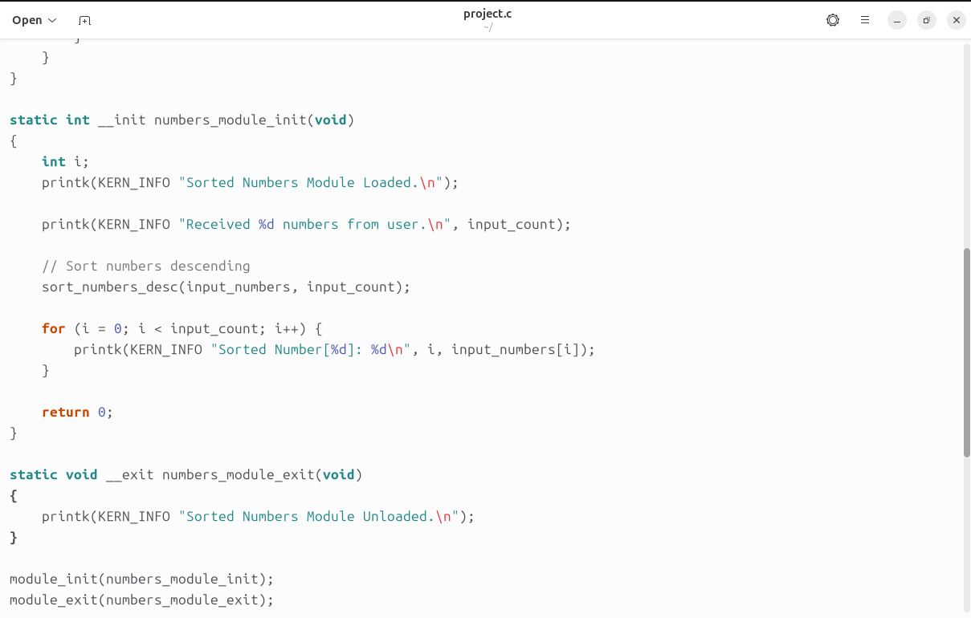
Note : file name is project.c

Step 2:
Making the Makefile
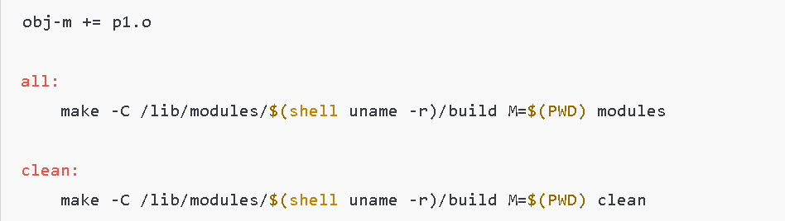

Step 3:
Write make in terminal to produce p1.ko
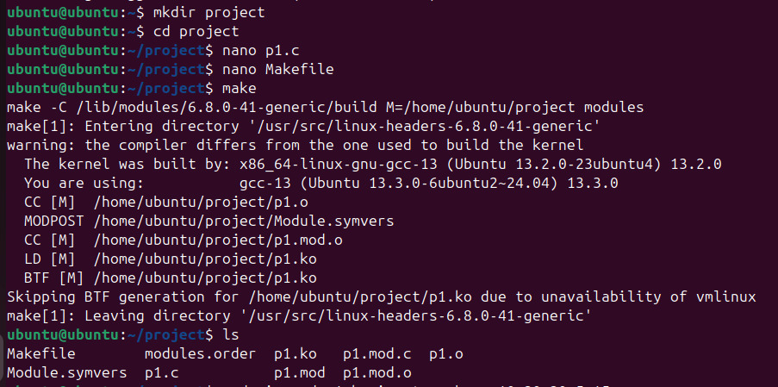

Step 4:
Write sudo insmod p1.ko in terminal with the parameters and sudo dmesg to display the message
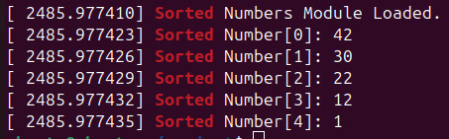

Step 5:
Write sudo rmmod project to remove it and sude dmesg to display another message
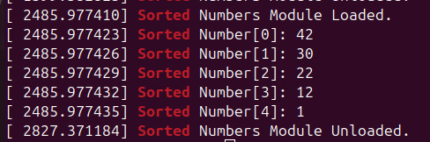

Conclusion
This Linux kernel module that accepts user input, processes the data, and outputs results to the kernel log.By using functions like printk.

